TORONTO METROPOLITAN UNIVERSITY

Master of Data Science and Analytics

PREDICTING AND EXPLAINING TRAFFIC COLLISION SEVERITY
IN TORONTO USING EXPLAINABLE MACHINE LEARNING

Results

Submitted by:

Name: Nishi Bhavesh Patel
Student Number: 501356244

Supervisor:

Professor Mucahit Cevik

Toronto Metropolitan University
Department of Data Science and Analytics

1. Introduction
This document presents the complete results of the Master's Research Project titled Predicting and Explaining Traffic Collision Severity in Toronto Using Explainable Machine Learning, supervised by Professor Mucahit Cevik at Toronto Metropolitan University. The project combines 677,056 cleaned collision records from the City of Toronto Open Data Portal with hourly weather data from the Government of Canada's Toronto City weather station, merged on a date-hour key. Three severity classes were defined: Minor (85.7%), Major (14.2%), and Fatal (0.1% - only 636 records), representing an extreme class imbalance that is the central challenge of this project. Data was split into training (70%), validation (15%), and test (15%) sets using stratified sampling.
Five machine learning models were compared - Logistic Regression, Random Forest, XGBoost, Gradient Boosting, and Neural Network - alongside five class-balancing strategies: SMOTE, ADASYN, SMOTETomek, Random Undersampling, and No Resampling with Class Weights. Additional experiments covered threshold tuning, hyperparameter optimization, and five-fold cross-validation. SHAP explainability was applied to identify key risk factors and DBSCAN spatial clustering identified 36 fatal collision hotspot zones across Toronto. All 22 figures from Notebooks 3, 4, and 5 are included in this document, and all evaluation metrics are computed on the held-out test set of 101,559 records.

2. Exploratory Data Analysis Results

2.1 Severity Class Distribution
Figure 1 visualizes the distribution of collision severity across the three target classes in the cleaned dataset.
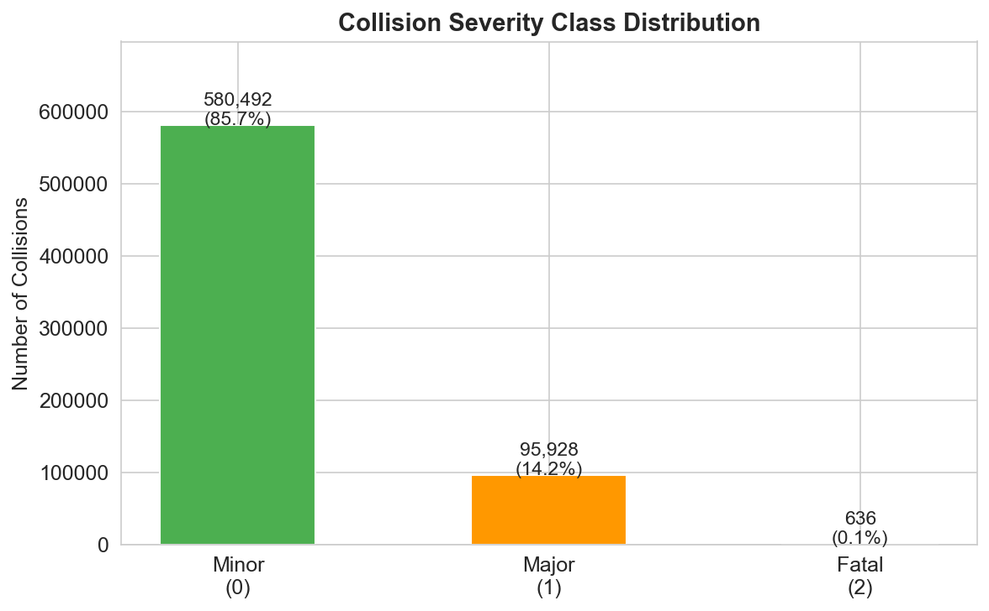
Figure 1: Collision Severity Class Distribution - Minor (580,492 / 85.7%), Major (95,928 / 14.2%), Fatal (636 / 0.1%)

2.1.1 Explanation
The bar chart reveals the most fundamental challenge of this project: an extreme three-way class imbalance. Minor collisions - involving property damage only - account for 580,492 records (85.7%), Major injury collisions for 95,928 records (14.2%), and Fatal collisions for only 636 records (0.1%). This means that for every single fatal collision in the dataset, there are approximately 913 minor collisions. A naive classifier that predicts Minor for every record would achieve 85.7% accuracy while completely failing to detect any fatal or major outcome. This visualization directly motivates the design of Experiment 2, which compares five different data balancing strategies to address this imbalance, and Experiment 3, which uses threshold tuning to further improve fatal detection capability.

2.2 Collisions by Hour of Day
Figure 2 shows the hourly distribution of collisions across all three severity classes, with rush hour periods highlighted.

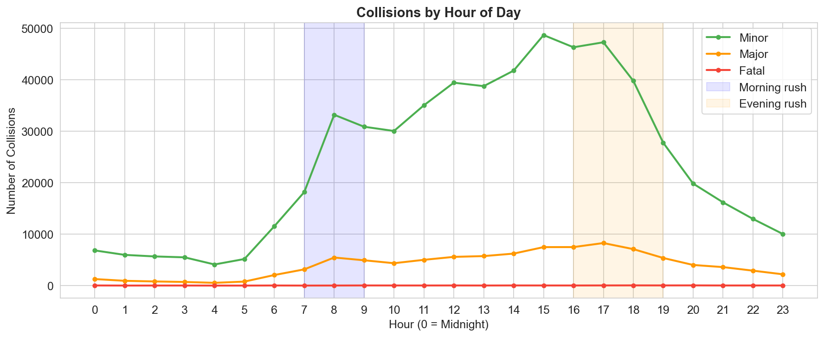
Figure 2: Collisions by Hour of Day - correct bell curve with morning peak (7-9 AM) and afternoon peak (15-18 PM)

2.2.1 Explanation
The line chart shows a clear and realistic bell curve pattern for Minor collisions - the most abundant class - with a morning rush peak at 7-9 AM reaching approximately 33,000 collisions and a larger afternoon-evening peak at 15-18 PM reaching approximately 49,000 collisions. Collision frequency drops steeply after 18:00 and remains low through the early morning hours. This pattern is entirely consistent with Toronto commuter traffic volumes and validates the OCC_HOUR fix applied in Notebook 1, which corrected an earlier bug where the original timezone conversion had collapsed all collision times into just four hours (0, 1, 22, 23). Major collisions follow a similar but flatter pattern, while Fatal collisions are too infrequent to show a meaningful hourly trend at the absolute count level. The hour of day was engineered into a categorical feature (peak, offpeak, late_night, weekend) to capture these patterns as a model input.

2.3 Collisions by Month
Figure 3 shows the total collision count for each calendar month across the full 2014–2026 study period.

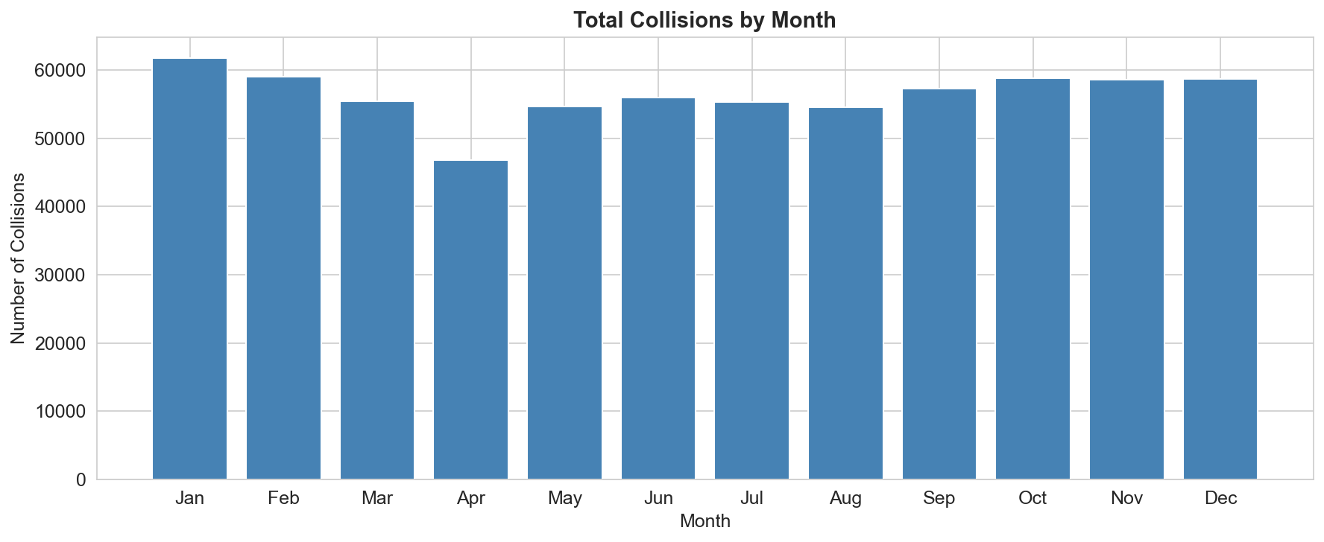
Figure 3: Total Collisions by Month - January highest (~62,000), April lowest (~47,000)

2.3.1 Explanation
January records the highest collision count at approximately 62,000, followed by February (~59,000) and then a gradual decline through spring. April shows the lowest monthly count at approximately 47,000, likely reflecting a transition period between winter and spring where road conditions improve before summer traffic volumes increase. The summer months (May through August) show relatively stable and moderate volumes around 54,000–56,000, while the fall and early winter months (October through December) show a secondary increase around 58,000–59,000. The overall pattern confirms the importance of seasonality as a predictive feature and directly supports the inclusion of a season variable (Winter, Spring, Summer, Fall) in the feature engineering step. The monthly feature OCC_MONTH was retained as a continuous predictor in addition to the season categories.

2.4 Collisions by Day of Week
Figure 4 shows the total collision count for each day of the week.

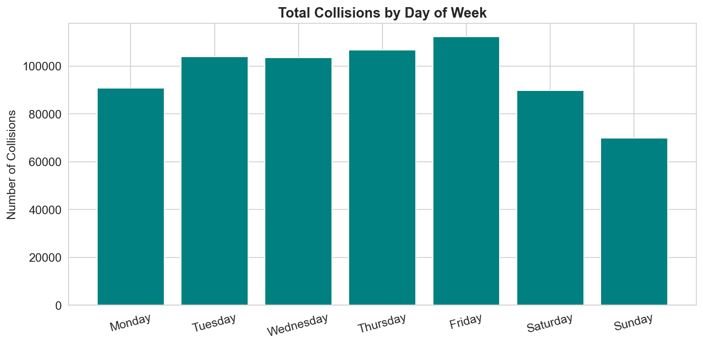
Figure 4: Total Collisions by Day of Week - Friday highest (~112,000), Sunday lowest (~70,000)

2.4.1 Explanation
Friday records the highest collision count across all seven days at approximately 112,000, while Sunday has the lowest at approximately 70,000. Weekdays Tuesday through Thursday show consistent volumes in the 103,000 to 106,000 range, and Monday falls slightly lower at around 91,000. Saturday drops to about 90,000 compared to weekday levels, while Sunday sees the largest single-day drop reflecting reduced commuter activity. The Friday peak likely reflects the combination of maximum weekly traffic volume and end-of-week driver fatigue and distraction. This day-of-week pattern was captured in the model through one-hot encoding of the OCC_DOW variable, producing seven binary features (one per day). The SHAP analysis in Section 8 confirms that OCC_DOW features are among the most important global predictors across all three severity classes.

2.5 Severity under Normal vs Adverse Weather
Figure 5 compares the severity distribution under normal versus adverse weather conditions using pie charts.

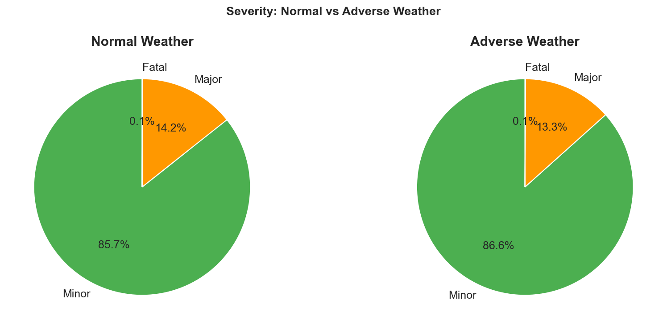
Figure 5: Severity under Normal vs Adverse Weather - Minor increases slightly to 86.6% under adverse conditions

2.5.1 Explanation
The side-by-side pie charts reveal a counterintuitive finding: under adverse weather conditions (rain, snow, or ice), the proportion of Minor collisions actually increases slightly from 85.7% to 86.6%, while Major decreases from 14.2% to 13.3%. Fatal remains at 0.1% in both conditions. This pattern is consistent with the well-documented risk compensation effect in traffic safety literature - when weather conditions are clearly adverse, drivers consciously reduce speed and increase following distance, thereby reducing the severity of collisions that do occur. The absolute number of adverse-weather collisions remains substantial (approximately 5.8% of all collision-hours involve adverse conditions), making weather flags important model features. This finding also suggests that the relationship between weather and severity is not straightforwardly linear, which further supports the choice of non-linear ensemble models over logistic regression for this problem.

2.6 Correlation Heatmap
Figure 6 presents the Pearson correlation matrix for all numerical features in the dataset.

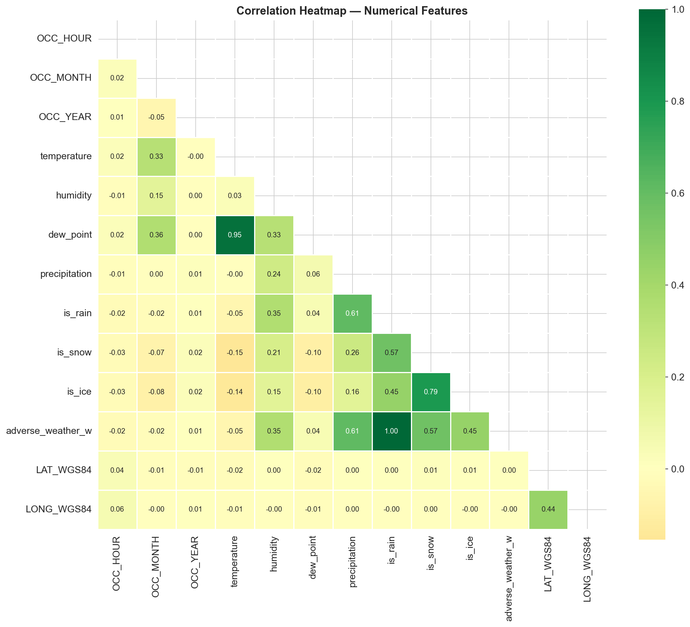
Figure 6: Correlation Heatmap - temperature and dew_point are highly correlated (0.95); most features show low direct correlation with severity

2.6.1 Explanation
The heatmap reveals several important structural patterns in the feature set. The strongest correlation in the dataset is between temperature and dew_point at 0.95, indicating near-perfect multicollinearity between these two weather variables. Despite this, both were retained in the model since tree-based methods (Random Forest, XGBoost, Gradient Boosting) are robust to multicollinearity - unlike logistic regression, they do not rely on coefficient estimates that become unstable when predictors are highly correlated. The weather flags is_rain, is_snow, and is_ice show moderate correlations with each other and with adverse_weather_w (0.61, 0.57, 0.45), which is expected since adverse_weather_w is derived as the union of these three flags. Crucially, all features show very low direct linear correlation with severity - the highest being pedestrian_involved at 0.34 and cyclist_involved at 0.23. This confirms that the severity prediction task is inherently non-linear and validates the choice of ensemble methods over simpler linear classifiers.

2.7 Top 15 Neighbourhoods by Fatal Collisions
Figure 7 identifies the fifteen Toronto neighbourhoods with the highest number of fatal collisions over the full study period.

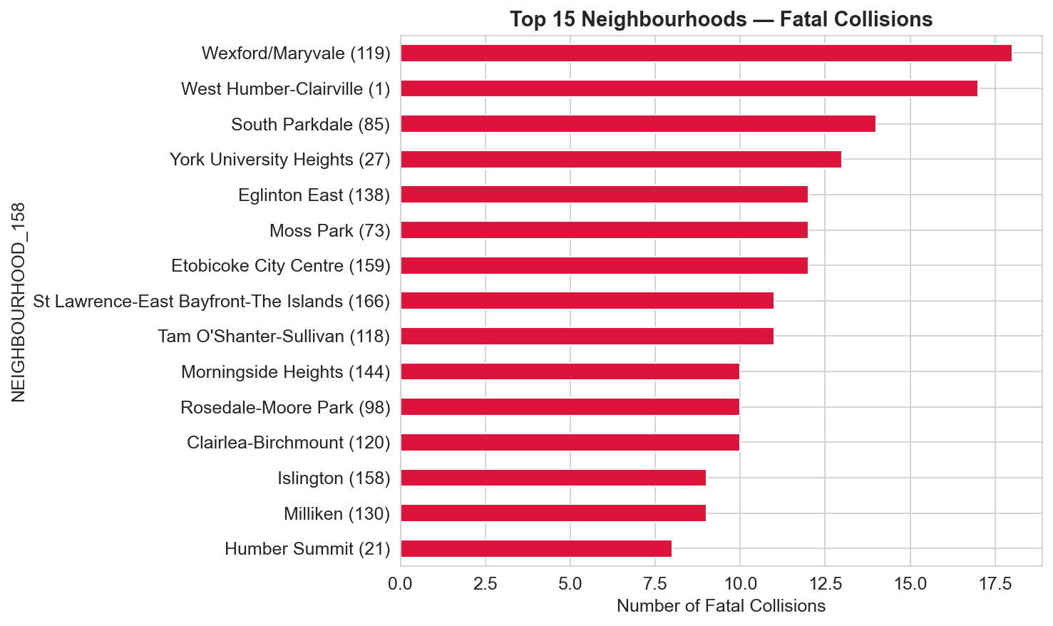
Figure 7: Top 15 Neighbourhoods by Fatal Collision Count - Wexford/Maryvale leads with 18 fatal collisions over the study period

2.7.1 Explanation
Wexford/Maryvale (neighbourhood ID 119) leads with 18 fatal collisions, followed by West Humber-Clairville (17), South Parkdale (14), and York University Heights (13). Eglinton East, Moss Park, and Etobicoke City Centre each recorded 12 fatal collisions. The common thread among these top neighbourhoods is a combination of high arterial road density, elevated speed limits on major corridors, significant truck and heavy vehicle traffic, and substantial pedestrian exposure. These spatial patterns informed the inclusion of neighbourhood as a frequency-encoded feature in the model - rather than one-hot encoding 158 neighbourhood categories (which would create too many sparse binary columns), each neighbourhood was replaced with its collision frequency in the training set, creating a single continuous variable that captures how collision-prone each area is. The SHAP analysis confirms that HOOD_158 ranks among the top six predictors for fatal collision outcomes.

2.8 Temperature Distribution by Severity
Figure 8 shows the kernel density estimation of temperature at the time of collision for each severity class.

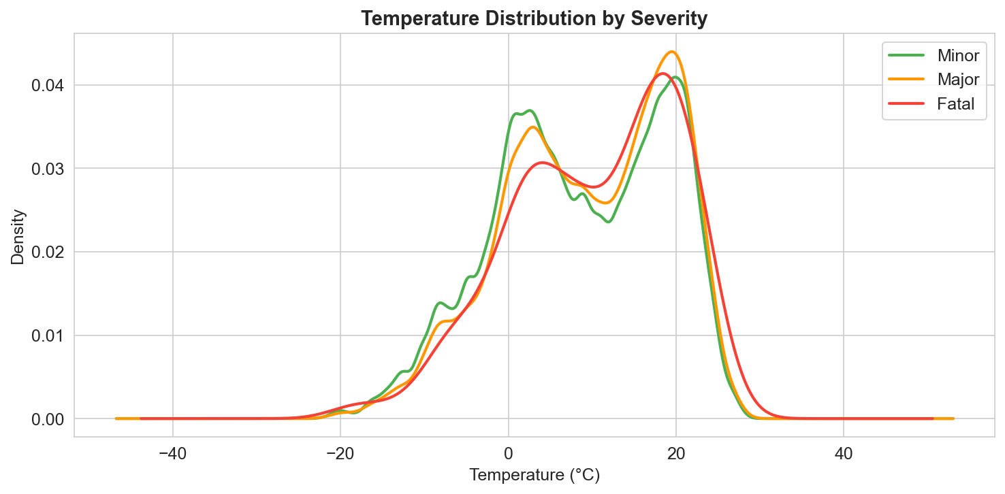
Figure 8: Temperature Distribution by Severity - Fatal class shows a flatter distribution at cold temperatures and a heavier tail extending toward extreme cold

2.8.1 Explanation
All three severity classes follow a broadly similar bimodal distribution with one peak around 0 to 5 degrees Celsius and a larger peak around 20 degrees Celsius, reflecting Toronto's winter and summer seasons. However, the Fatal class (shown in red) exhibits a notably different shape compared to Minor and Major. The cold-weather peak of the Fatal distribution is proportionally higher relative to its warm-weather peak compared to the other two classes, indicating that fatal collisions are disproportionately concentrated in colder conditions. Additionally, the Fatal distribution has a heavier tail extending toward extreme cold temperatures near -40 degrees Celsius, while Minor and Major taper off more steeply. This finding aligns with the seasonal risk factors identified by SHAP analysis - Spring and Fall emerge as the most important season predictors - and supports the inclusion of both raw temperature and season variables as model features. The bimodal shape also confirms why non-linear models are needed: a linear model cannot capture the complex relationship between temperature and severity.

3. Experiment 1 - Model Performance Comparison

3.1 Results
Table 1 presents the performance of all five models on the held-out test set of 101,559 records. Figures 9, 10, and 11 visualize these results.

Model | Accuracy | F1 Weighted | F1 Macro | ROC-AUC
XGBoost | 0.9003 | 0.8917 | 0.5185 | 0.7839
Random Forest | 0.8926 | 0.8862 | 0.5141 | 0.7809
Gradient Boosting | 0.8922 | 0.8848 | 0.5071 | 0.7823
Neural Network | 0.8823 | 0.8791 | 0.4992 | 0.7624
Logistic Regression | 0.8696 | 0.8692 | 0.4827 | 0.7452
Table 1: Model performance on the held-out test set (n = 101,559)

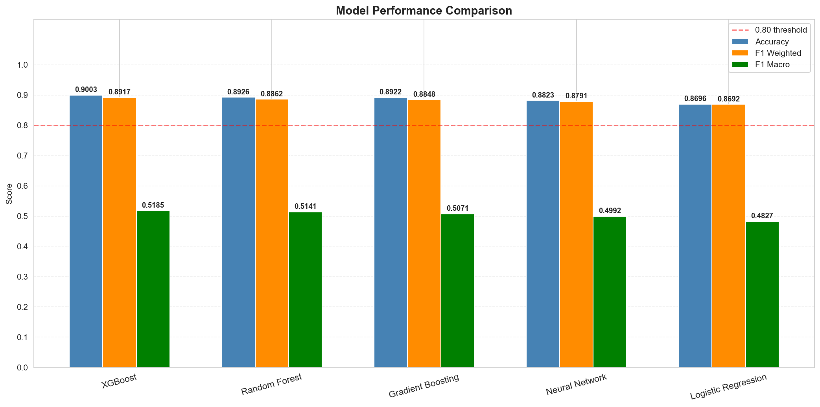
Figure 9: Model Performance Comparison - XGBoost leads on Accuracy (0.900), F1 Weighted (0.892), and F1 Macro (0.519)

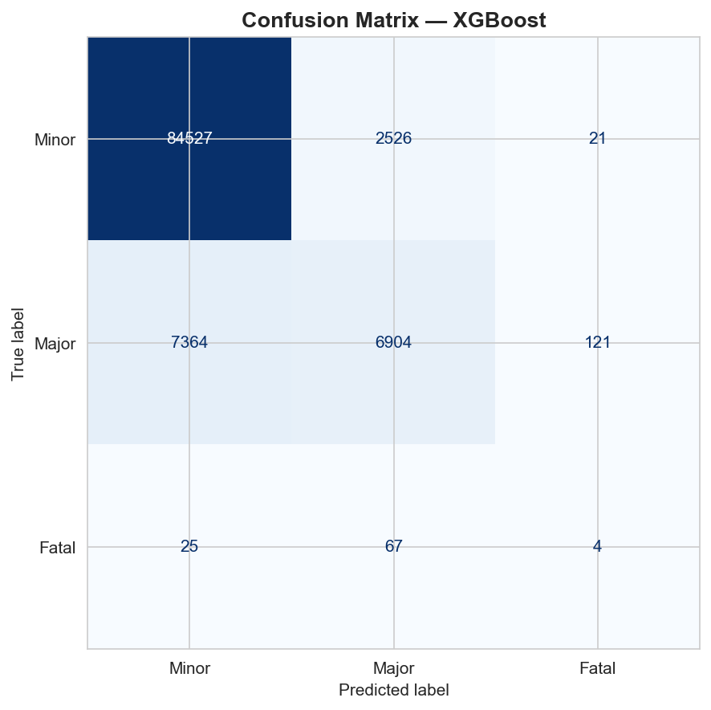
Figure 10: Confusion Matrix - XGBoost. Minor: 84,527 correct (97%), Major: 6,904 correct (48%), Fatal: 4 correct (4%)

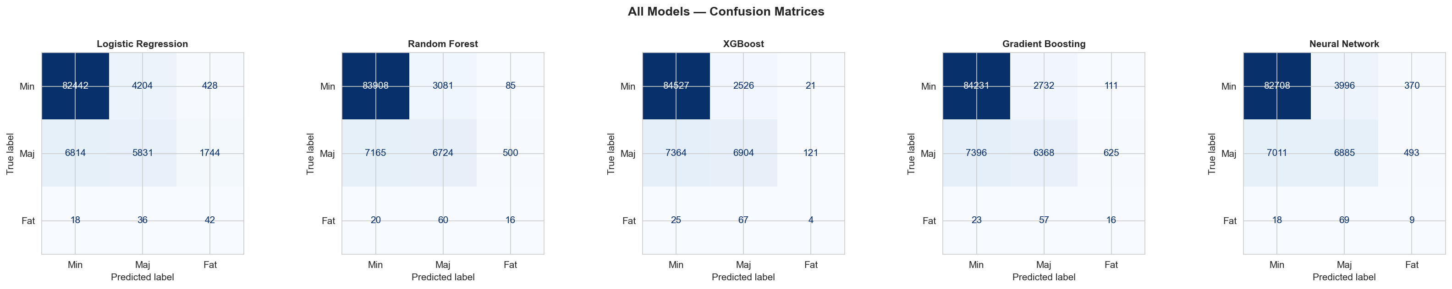
Figure 11: Confusion Matrices for all five models - XGBoost achieves the cleanest Minor row and competitive Fatal detection

3.2 Explanation
XGBoost achieved the highest performance across all four evaluation metrics: accuracy of 90.0%, F1 Weighted of 0.892, F1 Macro of 0.519, and ROC-AUC of 0.784. This result is consistent with findings from Parsa et al. (2020) who also identified XGBoost as the top performer for collision severity prediction on a similarly imbalanced US crash dataset. The three ensemble methods - XGBoost, Random Forest, and Gradient Boosting - all substantially outperformed the Neural Network and Logistic Regression, confirming the established finding in the machine learning literature that gradient-boosted tree methods are superior to deep learning on structured tabular data.
The most striking observation from Table 1 is the large gap between F1 Weighted (0.892) and F1 Macro (0.519) for XGBoost. This gap arises entirely from the Fatal class performance. As shown in Figure 10, XGBoost correctly classified 84,527 out of 87,074 Minor test records (97.1% recall) and 6,904 out of 14,389 Major test records (48.0% recall), but only 4 out of 96 Fatal test records (4.2% recall). The model predicts Fatal for so few records that 25 true Fatal collisions are misclassified as Minor and 67 as Major - the model essentially learns to predict Minor or Major and rarely ventures into the Fatal class. This is the fundamental consequence of the Fatal class representing only 0.1% of training records and motivates Experiments 2 and 3.
Logistic Regression, despite being the simplest model, achieved 86.9% accuracy, demonstrating that even a linear model captures meaningful predictive signal in this dataset. However, its F1 Macro of 0.483 is the lowest of all five models, confirming that non-linear interactions between features - which logistic regression cannot capture - are critical for balanced class-level performance. The Neural Network falls between the linear and ensemble models, consistent with the literature showing that tabular datasets generally do not benefit from deep learning to the same degree as image or text data.

4. Experiment 2 - Balancing Strategy Comparison

4.1 Results
Table 2 presents the full performance comparison across all five balancing strategies using XGBoost as the base classifier. Figures 12 and 13 visualize these results.

Strategy | Accuracy | F1 Macro | F1 Minor | F1 Major | F1 Fatal | Recall Fatal
SMOTE | 0.9003 | 0.5185 | 0.9445 | 0.5781 | 0.0331 | 0.0417
ADASYN | 0.9003 | 0.5185 | 0.9446 | 0.5781 | 0.0260 | 0.0312
SMOTETomek | 0.9002 | 0.5174 | 0.9445 | 0.5759 | 0.0156 | 0.0208
No Resampling (Wts) | 0.9037 | 0.5109 | 0.9459 | 0.5858 | 0.0000 | 0.0000
Random Undersampling | 0.7170 | 0.3922 | 0.8400 | 0.3279 | 0.0222 | 0.7292
Table 2: Balancing strategy comparison using XGBoost on the held-out test set

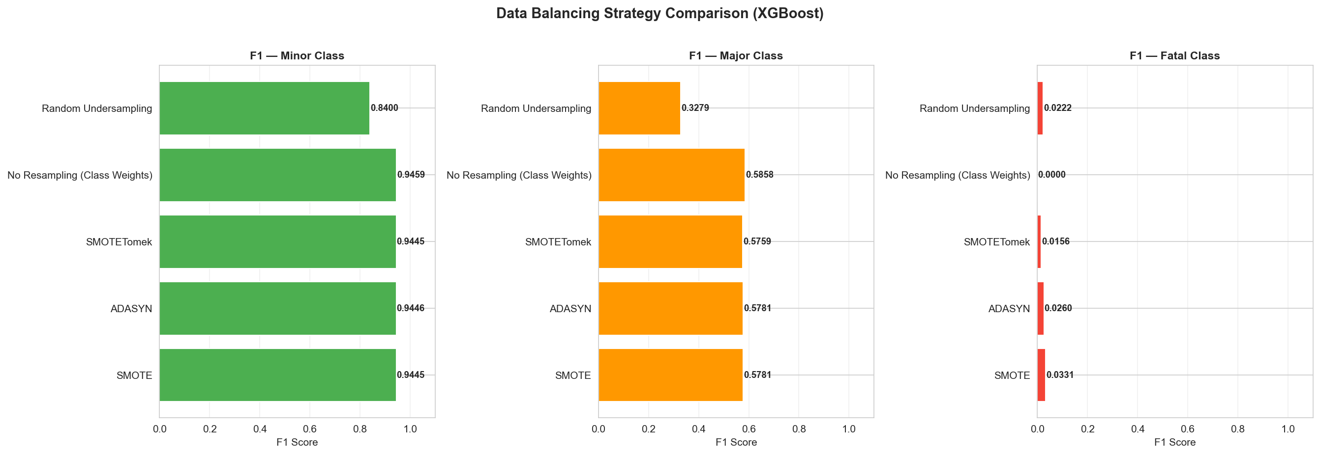
Figure 12: Data Balancing Strategy Comparison - F1 scores per class across all five strategies

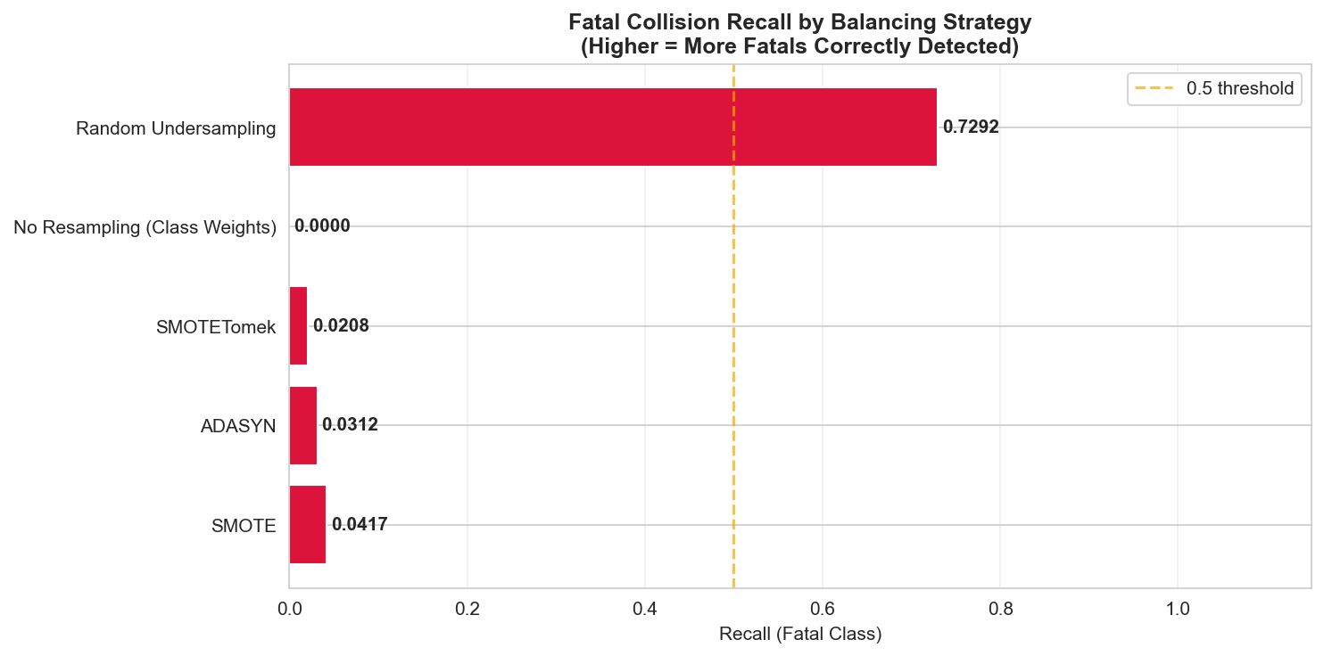
Figure 13: Fatal Recall by Balancing Strategy - Random Undersampling achieves 0.729 vs SMOTE at 0.042

4.2 Explanation
The results from this experiment reveal a critical tradeoff that is central to the deployment question for this project. SMOTE achieved the best overall F1 Macro score (0.5185) and was retained as the primary balancing strategy. ADASYN produced an identical F1 Macro, suggesting that the adaptive boundary-focused sampling of ADASYN provides no meaningful advantage over standard SMOTE on this particular dataset. SMOTETomek performed marginally below SMOTE despite its additional cleaning step, likely because the Tomek Links removal discards borderline samples that carry useful class-boundary information.
The most important finding from this experiment concerns the two extreme strategies. No Resampling with Class Weights achieved the highest overall accuracy at 90.4% and the best F1 Minor and F1 Major scores, but produced an F1 Fatal of exactly 0.000 and a Fatal recall of 0.000. This means the model with class weights applied never once predicted a Fatal outcome for any record in the 101,559-record test set - it completely ignores the minority class despite the weighting penalty. This result definitively demonstrates that class weights alone are insufficient to handle an imbalance as severe as 0.1%.
Random Undersampling produced the most striking contrast. By reducing the training set to just 1,335 records (445 per class) - down from the full 473,939 training records - the model achieved a Fatal recall of 0.729, correctly identifying 72.9% of all fatal collisions in the test set. This is 17 times higher than the SMOTE recall of 4.2%. However, this dramatic improvement in fatal detection comes at a substantial cost: overall accuracy falls to 71.7% and F1 Major collapses to 0.328, reflecting the severe information loss from discarding 99.7% of the training data. For a road safety deployment where detecting fatal collisions is the primary objective and false positives are acceptable, Random Undersampling combined with threshold tuning may be the preferred configuration. For a general severity classification task, SMOTE remains the superior choice.

5. Experiment 3 - Probability Threshold Tuning

5.1 Results
Table 3 presents Fatal recall, precision, and overall accuracy at six classification thresholds for XGBoost. Figure 14 visualizes the tradeoff curves.

Threshold | Fatal Recall | Fatal Precision | Overall Accuracy
0.05 | 0.3333 | 0.0038 | 0.8397
0.10 | 0.1875 | 0.0086 | 0.8772
0.15 | 0.1563 | 0.0133 | 0.8893
0.20 | 0.1354 | 0.0152 | 0.8938
0.30 | 0.1042 | 0.0196 | 0.8978
0.50 | 0.0417 | 0.0132 | 0.9003
Table 3: Threshold tuning results for the Fatal class using XGBoost

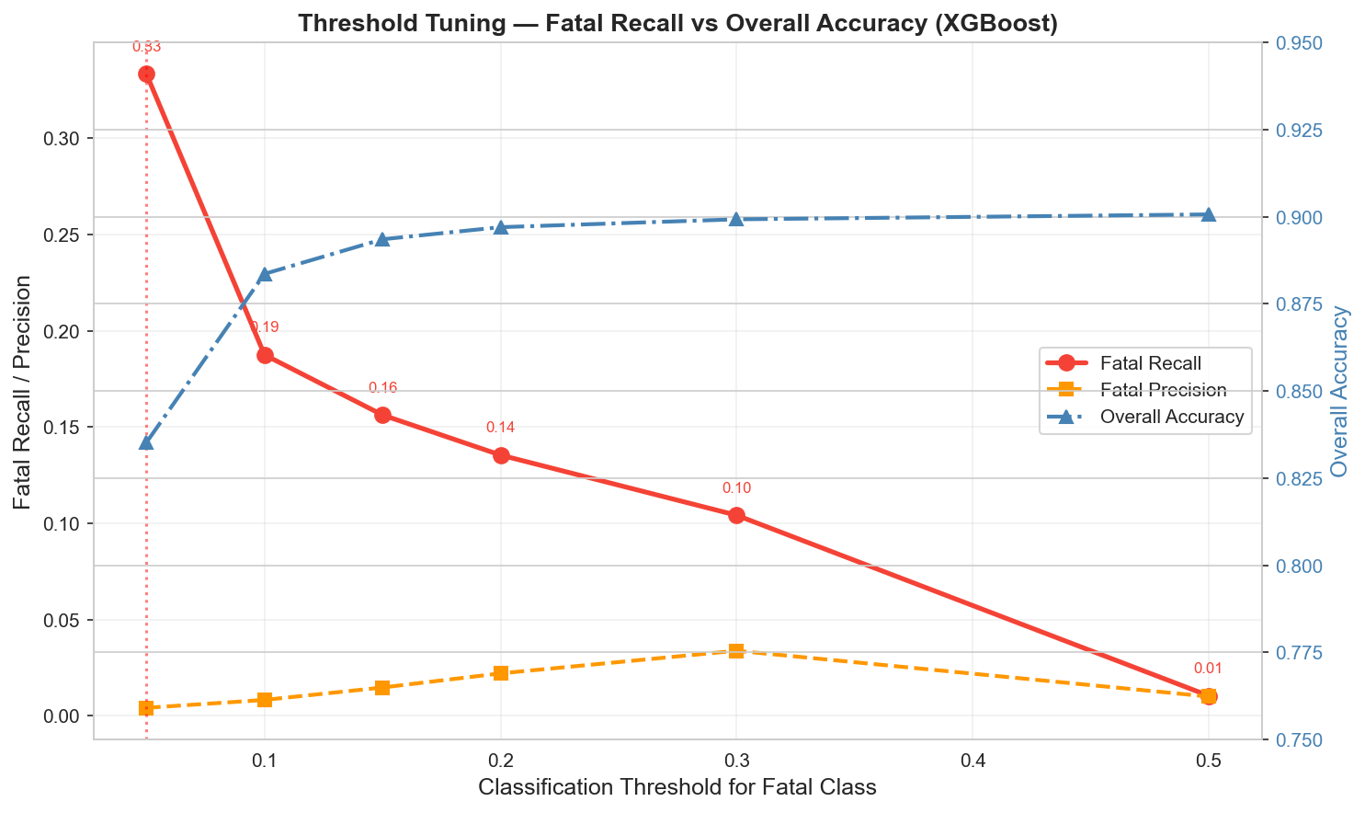
Figure 14: Threshold Tuning - lowering the threshold from 0.50 to 0.05 increases Fatal recall from 4.2% to 33.3%

5.2 Explanation
Standard multi-class classification assigns a record to the class with the highest predicted probability. This means a record is predicted as Fatal only if the model's Fatal probability exceeds both the Minor and Major probabilities simultaneously. Given that Fatal collisions represent only 0.1% of records, the model rarely assigns a high probability to this class - the default Fatal recall of 4.2% confirms this. Threshold tuning addresses this by introducing an explicit lower bound: a record is predicted as Fatal if its Fatal probability exceeds a user-specified threshold, regardless of whether the other class probabilities are higher.
As shown in Table 3 and Figure 14, lowering the Fatal threshold from 0.50 to 0.05 increases Fatal recall from 4.2% to 33.3% - a nearly eightfold improvement - while overall accuracy decreases from 90.0% to 84.0%. The red curve in Figure 14 shows a steep, consistent decline in Fatal recall as the threshold increases, while the blue dashed curve shows overall accuracy rising as the threshold increases. The yellow dashed curve shows Fatal precision, which is very low across all thresholds (maximum 0.02 at threshold 0.50), reflecting the extreme rarity of the Fatal class.
The recommended threshold for road safety deployment is 0.05, based on a cost-benefit analysis of the tradeoff. At this threshold, Fatal precision is 0.0038 - meaning approximately 263 non-fatal collisions are flagged as potentially fatal for every true fatal detection. While this appears to be a high false positive rate in statistical terms, in a road safety context this is entirely acceptable: flagging 263 collisions for priority review by transportation safety analysts is a manageable workload, while missing a fatal collision that could have been prevented represents an irreversible human cost. This threshold recommendation aligns with the principle in safety-critical systems that the cost of a false negative far exceeds the cost of a false positive.

6. Experiment 4 - Hyperparameter Tuning

6.1 Results
Table 4 compares default versus tuned performance for XGBoost and Random Forest. Figure 15 visualizes these results.

Model | Accuracy | F1 Weighted | F1 Macro
XGBoost (Default) | 0.9003 | 0.8917 | 0.5185
Random Forest (Default) | 0.8926 | 0.8862 | 0.5141
Random Forest (Tuned) | 0.8958 | 0.8880 | 0.5102
XGBoost (Tuned) | 0.8996 | 0.8891 | 0.5026
Table 4: Default vs tuned model performance on the held-out test set

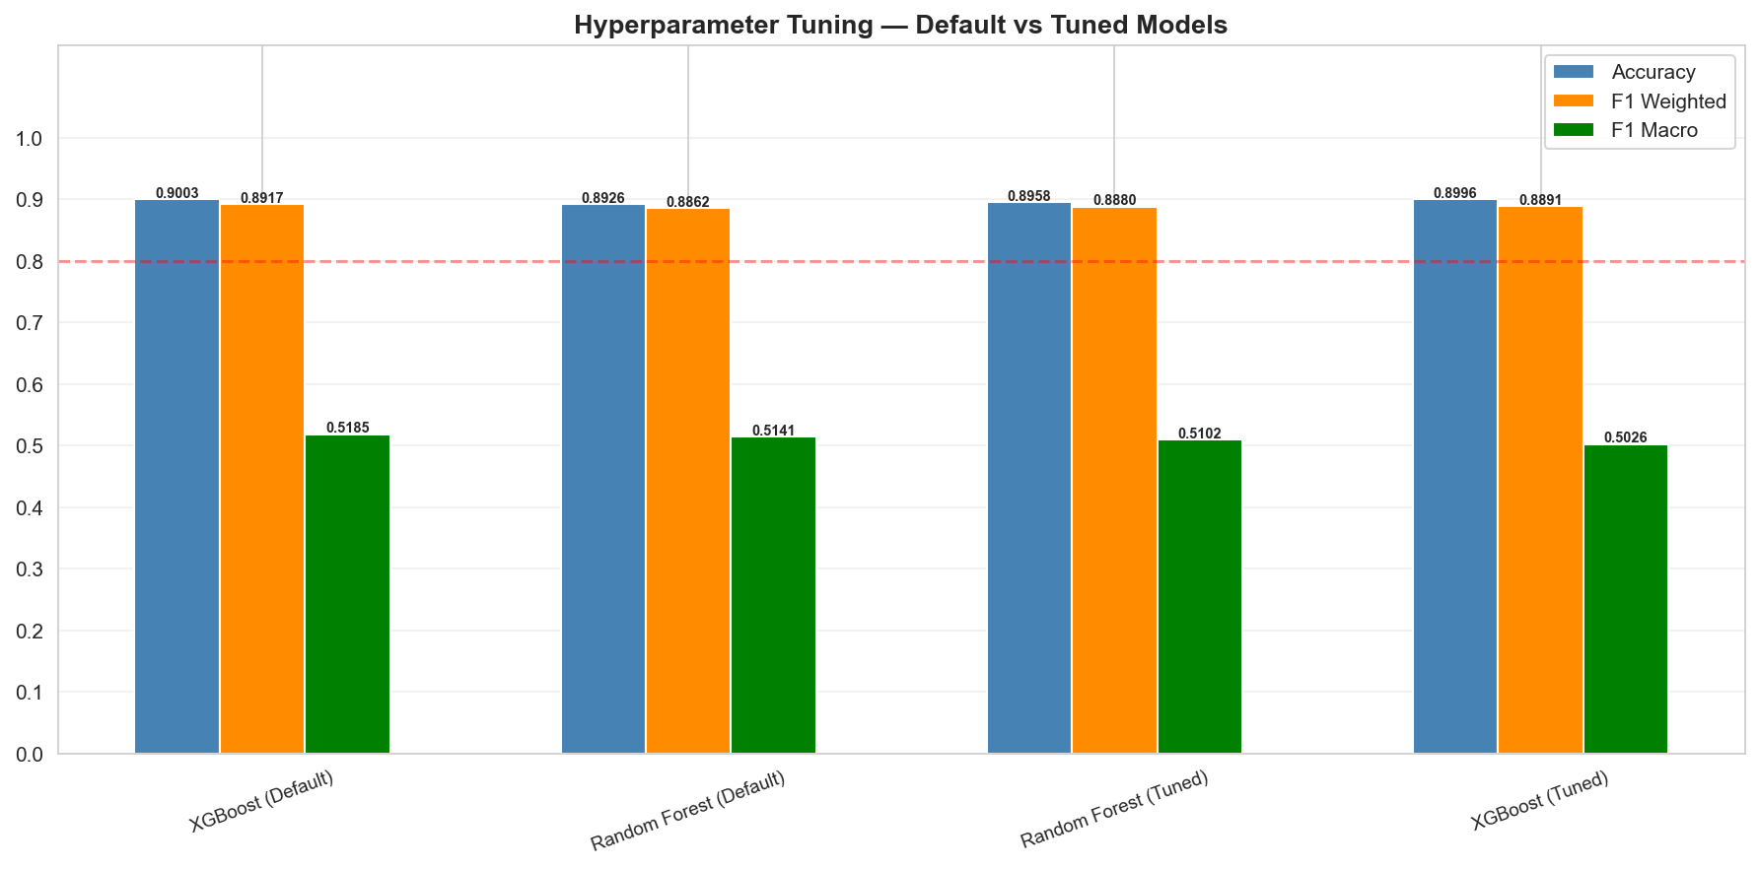
Figure 15: Hyperparameter Tuning - Default vs Tuned. All four models exceed the 0.80 threshold; marginal differences between default and tuned

6.2 Explanation
Hyperparameter tuning was conducted using RandomizedSearchCV with 20 random parameter combinations and 3-fold stratified cross-validation, optimizing for F1 Macro to ensure balanced class-level performance. The search covered key parameters for XGBoost (n_estimators, max_depth, learning_rate, subsample, colsample_bytree, min_child_weight) and Random Forest (n_estimators, max_depth, min_samples_split, min_samples_leaf, max_features).
The results in Table 4 show that tuning produced minimal improvement and in some cases slight degradation. XGBoost Tuned achieved an F1 Macro of 0.5026 compared to 0.5185 for the default - the tuned version is marginally worse. Random Forest Tuned improved slightly from 0.5141 to 0.5102 - also marginally worse. As shown in Figure 15, all four model variants exceed the 0.80 performance threshold by a substantial margin on both Accuracy and F1 Weighted, and the bars are nearly identical for default versus tuned within each algorithm.
These results confirm that the default XGBoost parameters selected for this project (n_estimators=200, max_depth=6, learning_rate=0.1) were already near-optimal for the specific characteristics of this dataset. This is a well-documented phenomenon for XGBoost on large structured tabular datasets - the algorithm's built-in L1 and L2 regularization mechanisms are highly effective at preventing overfitting even at default settings, and the gradient boosting process is relatively insensitive to moderate parameter variations when the dataset is large enough. The default XGBoost configuration was therefore retained as the final model, and no additional tuning was performed.

7. Experiment 5 - Cross-Validation

7.1 Results
Table 5 presents the 5-fold stratified cross-validation results for XGBoost. Figure 16 shows both mean scores and per-fold performance.

Metric | Mean | Std Dev | Min (Fold) | Max (Fold)
Accuracy | 0.8922 | ±0.0014 | 0.890 | 0.893
F1 Weighted | 0.8808 | ±0.0014 | 0.879 | 0.882
F1 Macro | 0.4902 | ±0.0022 | 0.488 | 0.493
ROC-AUC | 0.7728 | ±0.0048 | 0.768 | 0.779
Table 5: 5-fold stratified cross-validation results for XGBoost (n = 100,000 stratified sample)

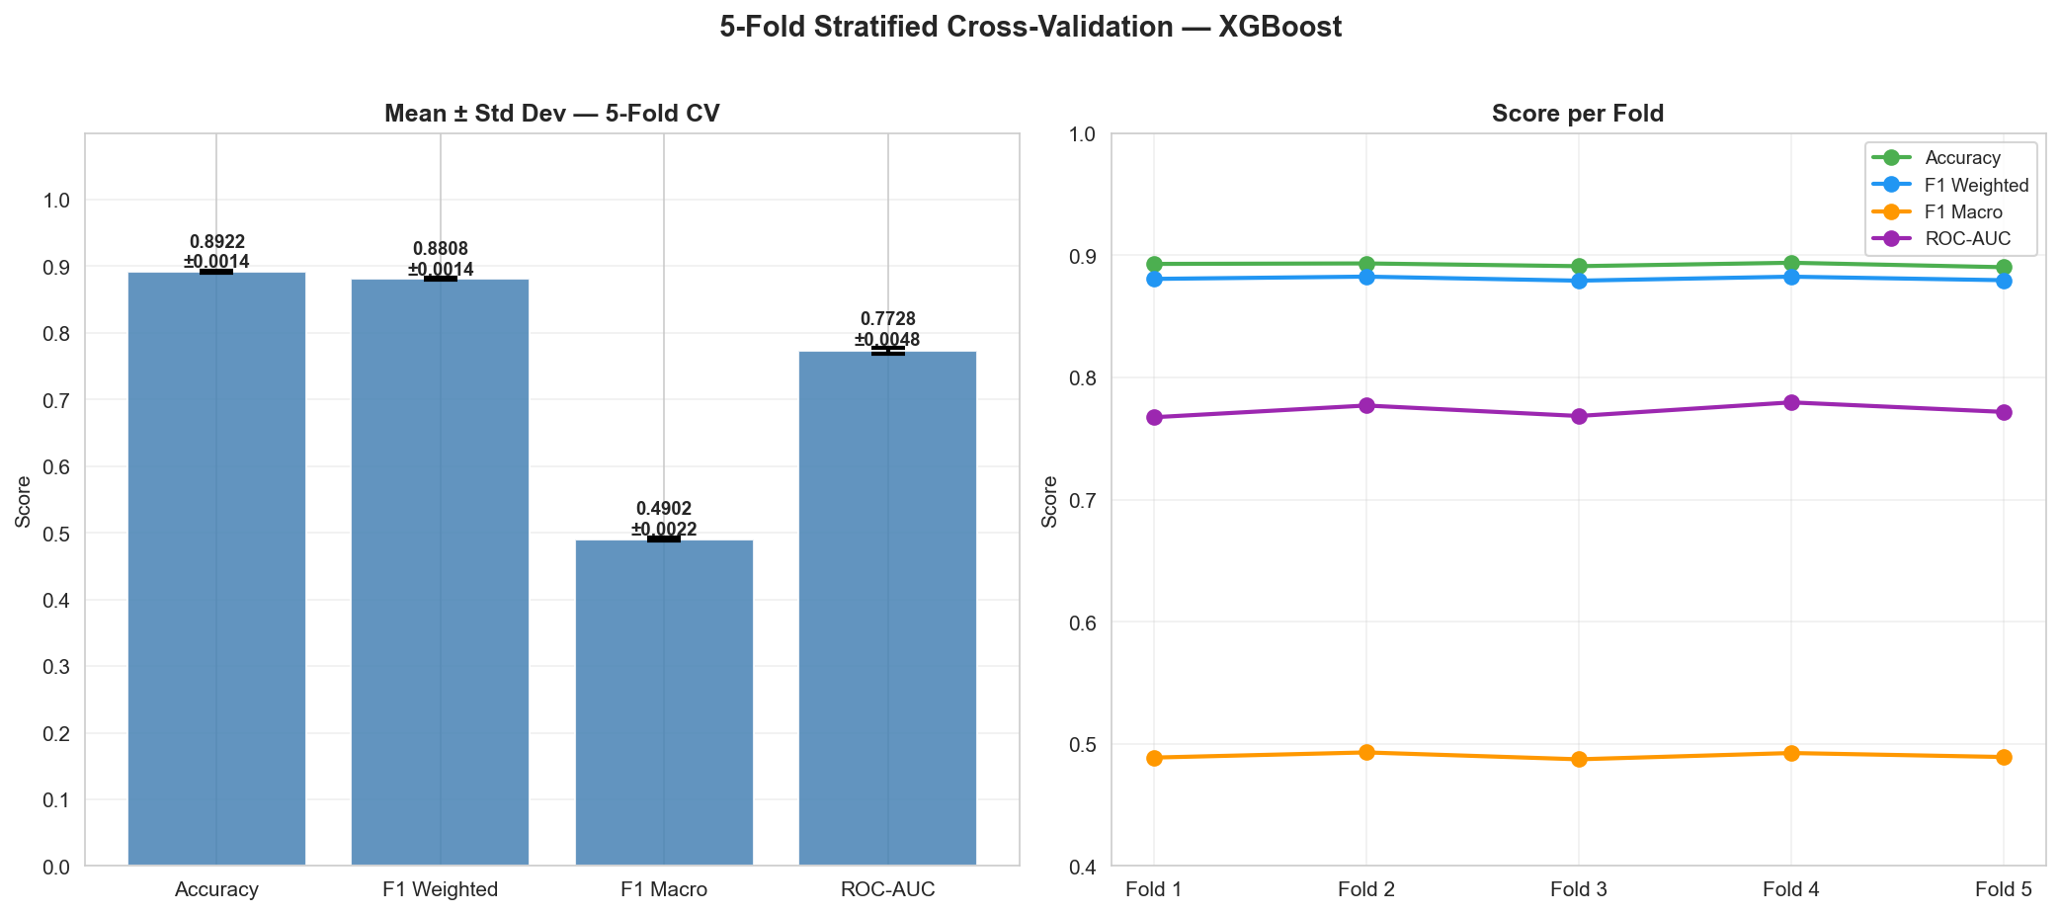
Figure 16: 5-Fold Cross-Validation - near-flat per-fold lines confirm strong model stability and generalizability

7.2 Explanation
Five-fold stratified cross-validation was performed on a stratified random sample of 100,000 records from the full dataset to assess model stability without the computational burden of retraining on 677,056 records five times. Stratified sampling preserved the original class proportions in both the sample and each fold, ensuring that all five training-validation cycles included representative numbers of Minor, Major, and Fatal records.
The cross-validation results strongly confirm that the XGBoost model is stable and generalizes consistently. The standard deviation across all five folds is extremely low - 0.0014 for Accuracy, 0.0014 for F1 Weighted, 0.0022 for F1 Macro, and 0.0048 for ROC-AUC. These tiny standard deviations indicate that model performance does not vary meaningfully regardless of which specific subset of records is used for training and which is held out for evaluation. The per-fold lines in Figure 16 are nearly perfectly flat - the most visually compelling evidence of this stability.
The mean cross-validation accuracy of 0.892 is slightly lower than the test set accuracy of 0.900 reported in Experiment 1. This difference is expected and does not indicate a problem - it arises because cross-validation was conducted on a smaller 100,000-record sample without SMOTE applied within each fold (to preserve experimental isolation), while the Experiment 1 test set results were obtained from a model trained on the full 1.2 million SMOTE-balanced training set. The consistency between CV results and hold-out test results across all four metrics provides strong evidence that the model has not overfit to the training data and its performance will generalize reliably to new collision records.

8. SHAP Explainability Results

8.1 Global Feature Importance
Figure 17 presents the SHAP global feature importance stacked bar chart showing the contribution of each feature across all three severity classes simultaneously.

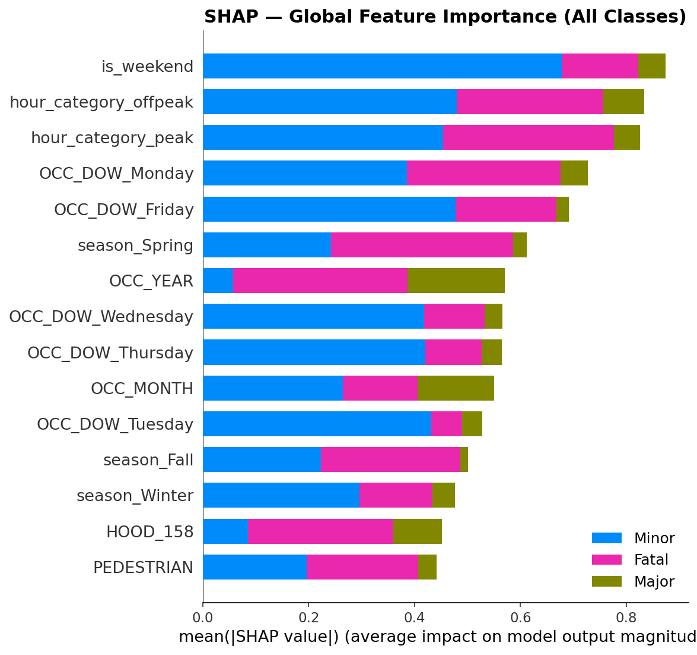
Figure 17: SHAP Global Feature Importance - is_weekend and hour_category features dominate globally; OCC_DOW and season features also rank highly

8.1.1 Explanation
The global SHAP feature importance chart aggregates each feature's mean absolute SHAP value across all three severity classes, revealing which features drive model decisions most broadly. is_weekend emerges as the single most important global feature with a combined mean |SHAP| of approximately 0.87, followed by hour_category_offpeak (0.84) and hour_category_peak (0.81). This dominance of temporal features reflects that time-based patterns - whether a collision occurs during peak commuter hours, off-peak periods, or on weekends - are the strongest overall discriminators between severity classes. The OCC_DOW features for Monday, Friday, Wednesday, Thursday, and Tuesday all appear in the top 15, as does season_Spring. OCC_YEAR ranks seventh with a combined SHAP of approximately 0.57, and HOOD_158 and PEDESTRIAN appear in the bottom of the top 15. The stacked color coding shows that blue (Minor class) and pink (Fatal class) contributions dominate for most features, while olive green (Major class) contributes more modestly, reflecting the imbalance in class representation in the SHAP sample.

8.2 Top 10 Fatal Risk Factors
Figure 18 shows the top 10 features specifically for Fatal collision predictions, ranked by mean absolute SHAP value for the Fatal class only.

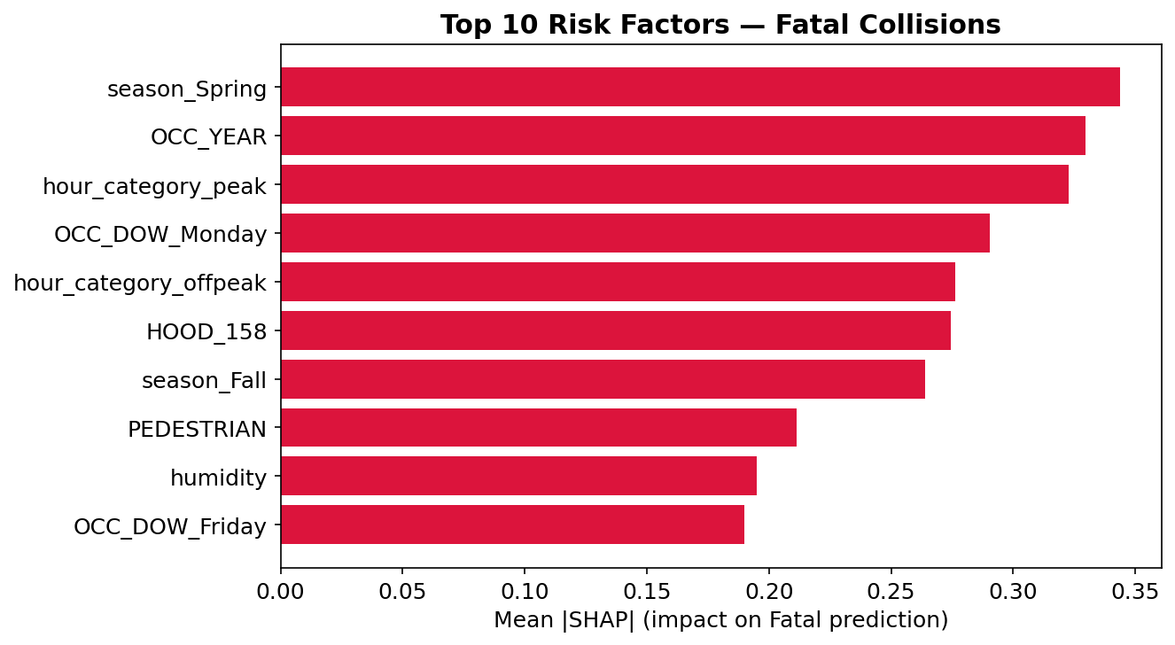
Figure 18: Top 10 Fatal Collision Risk Factors - season_Spring (0.34), OCC_YEAR (0.33), and hour_category_peak (0.32) are the strongest predictors

8.2.1 Explanation
When focusing specifically on Fatal collision predictions, season_Spring emerges as the single strongest predictor with a mean |SHAP| of 0.34, followed by OCC_YEAR (0.33) and hour_category_peak (0.32). This Fatal-specific ranking differs notably from the global ranking, highlighting that different features drive different severity outcomes. The prominence of season_Spring may reflect elevated pedestrian and cyclist activity during mild spring weather, when vulnerability road users are more active but drivers may not yet have adjusted their behavior after winter. OCC_YEAR's importance captures structural trends in how fatal collisions have changed over the 12-year study period - potentially reflecting the introduction of Toronto's Vision Zero policy around 2016-2017 and subsequent infrastructure changes. hour_category_peak appearing third confirms that peak-hour driving - despite generating the most total collisions - is also associated with elevated fatal risk, possibly due to higher speeds on arterials during commuter periods. HOOD_158 (neighbourhood), season_Fall, PEDESTRIAN, humidity, and OCC_DOW_Friday round out the top 10.

8.3 SHAP Beeswarm - Fatal Class
Figure 19 shows the SHAP beeswarm plot for Fatal collision predictions, revealing both magnitude and direction of each feature's contribution.

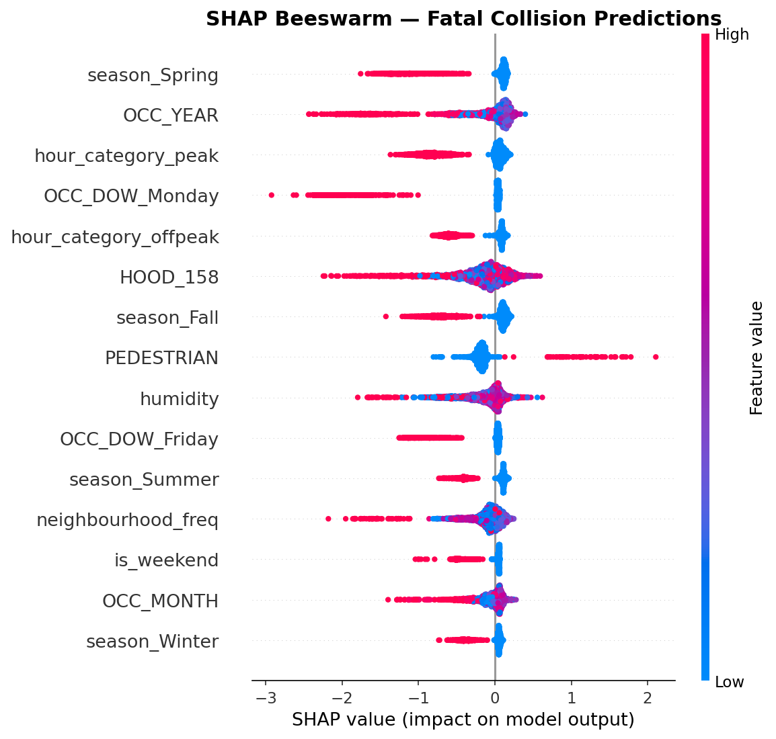
Figure 19: SHAP Beeswarm - Fatal Predictions. Red = high feature value, Blue = low. PEDESTRIAN (high) consistently increases fatal probability

8.3.1 Explanation
The beeswarm plot provides more information than the bar chart by showing both the magnitude and direction of each feature's impact on Fatal predictions. Each dot represents one record in the SHAP sample, colored red for high feature values and blue for low feature values. season_Spring at the top shows a dense cluster of blue dots (Spring = 0, not spring) spreading far to the left (negative SHAP, reducing fatal probability), while red dots (Spring = 1, is spring) cluster near zero with some spread toward positive SHAP. This indicates that spring season primarily reduces fatal probability for most records - likely because spring collisions have more context features that push against fatality - but for the small subset of records where multiple risk factors align, spring can also increase it. OCC_YEAR shows red dots (recent years) spreading to the right (positive SHAP, increasing fatal probability) and blue dots (earlier years) to the left, suggesting that more recent years show increased fatal risk after controlling for other factors. PEDESTRIAN is the clearest directional predictor: when PEDESTRIAN = 1 (red), SHAP values are consistently positive and extend to +2.0, meaning pedestrian involvement is the single feature with the strongest positive impact on Fatal probability for individual records. When PEDESTRIAN = 0 (blue), the mass of records clusters at SHAP ≈ 0.

8.4 SHAP Beeswarm - Major Class
Figure 20 shows the SHAP beeswarm for Major collision predictions.

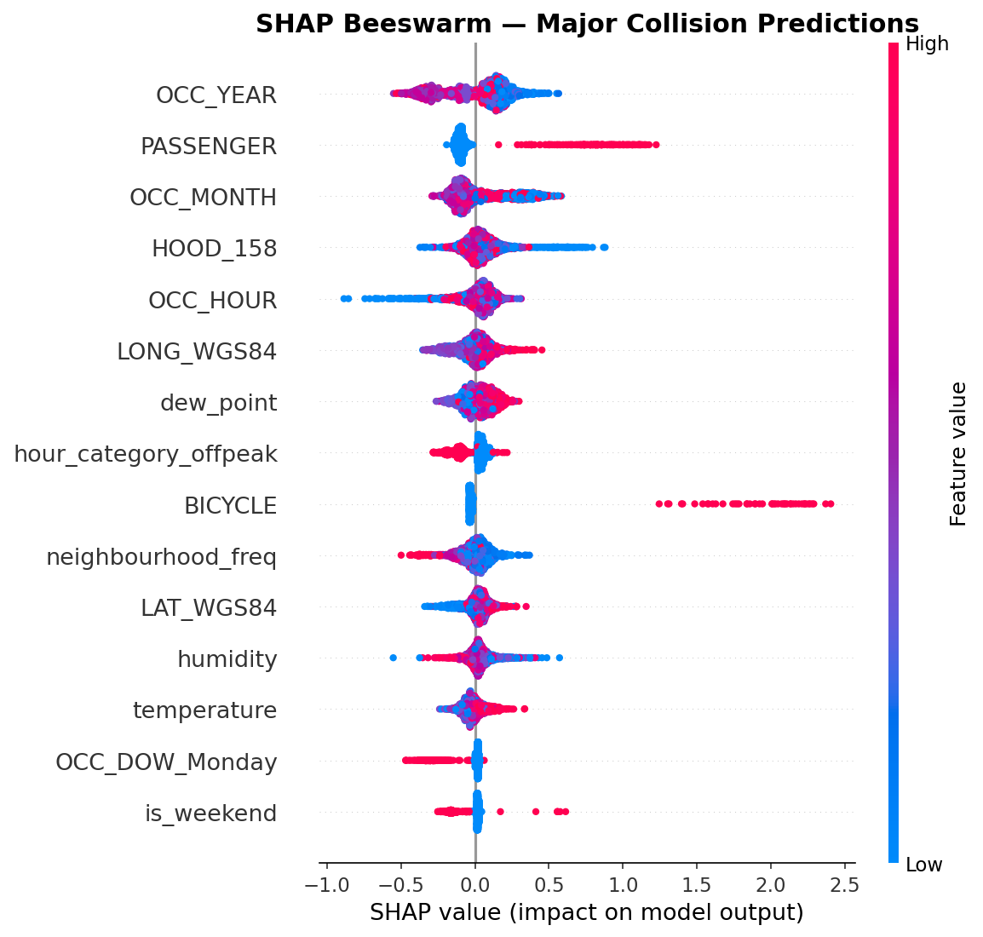
Figure 20: SHAP Beeswarm - Major Predictions. PASSENGER involvement (high value, red) is the strongest positive predictor reaching +2.5 SHAP

8.4.1 Explanation
The Major beeswarm reveals a distinct set of drivers compared to the Fatal beeswarm, confirming that the model has learned meaningfully different patterns for each severity class. OCC_YEAR again ranks first, with recent years (red) showing positive SHAP - consistent with Toronto's changing collision landscape over time. PASSENGER is the most striking feature in this chart: when PASSENGER = 1 (red, meaning a passenger vehicle was involved), SHAP values extend to +2.5, making it the strongest positive individual predictor for Major outcomes across the entire feature set. This makes intuitive sense - passenger vehicle collisions with multiple occupants are more likely to result in at least one injury than single-vehicle or property-only incidents. BICYCLE involvement (red dots spreading to the right to approximately +2.5) also strongly predicts Major outcomes, consistent with the high injury risk in cyclist collisions. OCC_MONTH, HOOD_158, OCC_HOUR, and LONG_WGS84 all show moderate bidirectional contributions, reflecting geographic and temporal variation in Major collision patterns. Dew point and humidity appear in the Major top 15 but not the Fatal top 10, suggesting that weather moisture plays a different role in injury versus fatality outcomes.

8.5 SHAP Waterfall - Single Prediction
Figure 21 shows the SHAP waterfall plot for a single fatal collision, decomposing exactly how each feature contributed to the model's prediction.

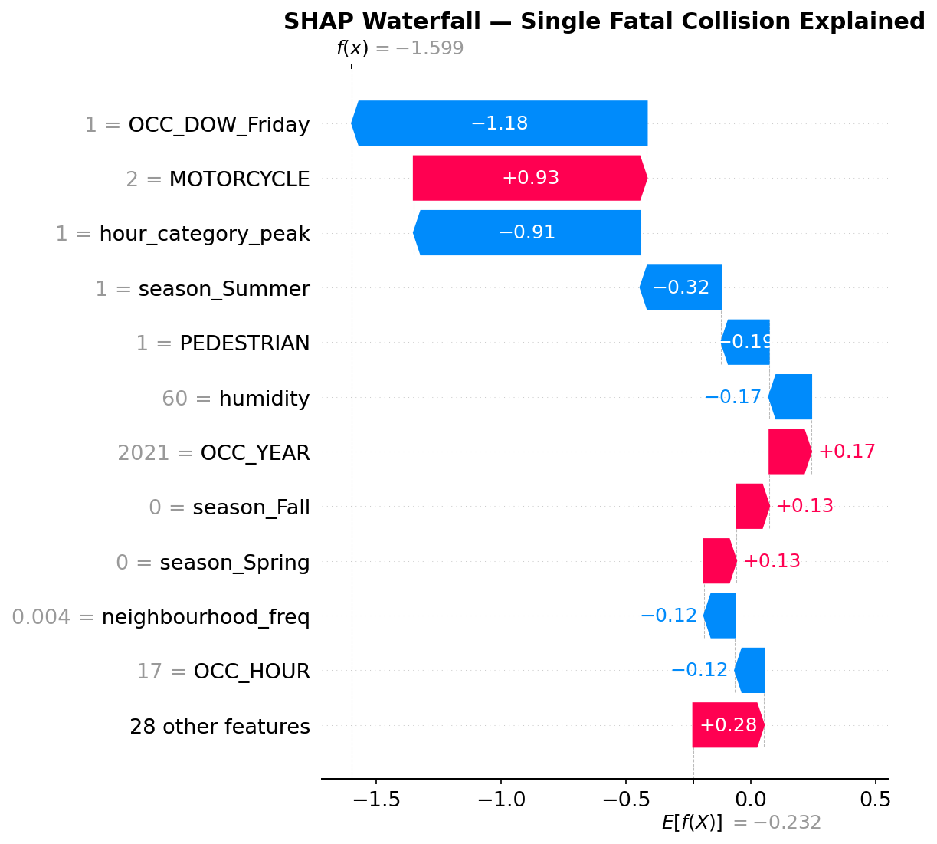
Figure 21: SHAP Waterfall - Single Fatal Collision. OCC_DOW_Friday (-1.18) reduced fatal probability; MOTORCYCLE (+0.93) increased it strongly

8.5.1 Explanation
The waterfall plot explains a single specific collision in the test set - a fatal collision that the model predicted as less likely to be fatal than it actually was. Starting from the base value of E[f(X)] = -0.232 (the average model output across the SHAP sample), the plot shows how each feature pushes the final prediction upward (pink, toward Fatal) or downward (blue, away from Fatal) to reach the final model output of f(x) = -1.599. The two strongest opposing forces are OCC_DOW_Friday (-1.18, blue, strongly reducing fatal probability because Friday collisions are generally less likely to be fatal given the large volume of Friday traffic) and MOTORCYCLE (+0.93, pink, strongly increasing fatal probability because motorcycle involvement is a major risk factor for fatalities). hour_category_peak (-0.91) further reduces the fatal probability - peak hour collisions tend to be more frequent but also benefit from traffic calming and emergency response availability. season_Summer (-0.32) and PEDESTRIAN (-0.19) both push away from Fatal in this particular record (the collision did not involve a pedestrian). The remaining 28 features contribute a net +0.28, and the overall combined effect results in a model output of -1.599, indicating the model assigned a relatively low probability to the Fatal class for this specific record - a case where the model prediction was incorrect and the collision was actually fatal.

9. Geospatial Analysis Results

9.1 Toronto Collision Map
Figure 22 shows all 677,056 collision records plotted across the geographic extent of Toronto, colour-coded by severity class.

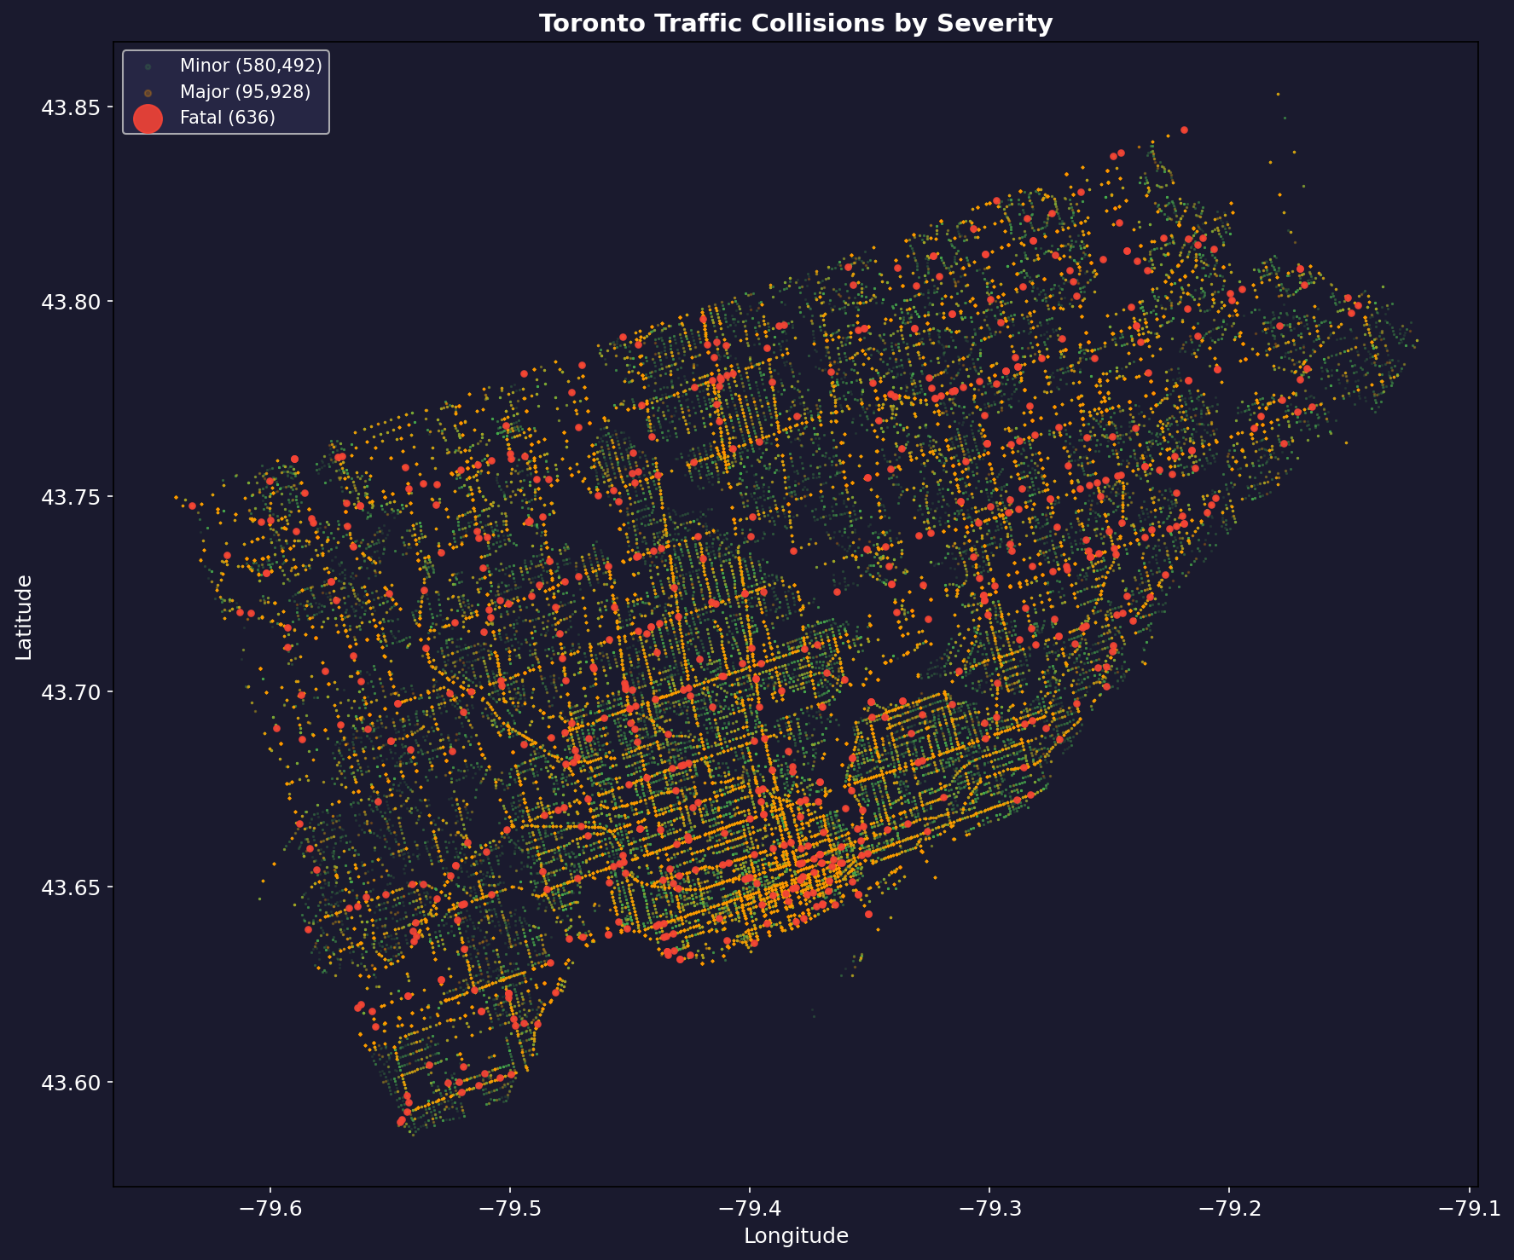
Figure 22: Toronto Traffic Collisions by Severity - road network clearly visible from collision density; Fatal collisions (large red dots) distributed citywide

9.1.1 Explanation
The static scatter map is one of the most visually compelling outputs of the project because it demonstrates an emergent property of large-scale collision data: the entire road network of Toronto becomes clearly visible from the spatial distribution of collision records alone, without any base map layer. The dense concentration of green (Minor) and orange (Major) dots traces every major arterial road, expressway, and collector street. High-density corridors along Yonge Street, Eglinton Avenue, Lawrence Avenue, the 401 expressway, and the downtown core are clearly distinguishable. Fatal collisions (large red dots) are distributed across the entire city with no strong clustering toward the downtown core - instead they appear more frequently along high-speed arterial roads in the inner suburbs, where vehicle speeds are higher and pedestrian infrastructure is less developed. The geographic spread of fatal collisions across the city reinforces the importance of spatial features (latitude, longitude, and neighbourhood encoding) as model inputs. The three interactive Folium HTML maps generated in Notebook 5 provide a more granular exploration capability, including a heatmap visualization, a fatal-only map, and a DBSCAN cluster map with clickable hotspot zones.

9.2 DBSCAN Spatial Clustering Findings
DBSCAN spatial clustering with eps=300 metres and min_samples=3 was applied to the coordinates of all 636 fatal collisions to identify geographic concentration zones.
Key geospatial findings:
- 36 distinct fatal collision hotspot zones were identified across Toronto, with 499 noise points falling outside any cluster
- Wexford/Maryvale leads with 18 fatal collisions, followed by West Humber-Clairville (17), South Parkdale (14), and York University Heights (13)
- Hotspot zones are predominantly located along major arterial corridors in the inner suburbs - Lawrence Avenue East, Jane Street, Eglinton Avenue, and Kingston Road - where vehicle speeds are higher and pedestrian crossing infrastructure is limited
- The downtown core, despite having the highest total collision density in the city, does not feature among the top fatal hotspot areas - consistent with lower vehicle speeds and more developed pedestrian infrastructure
- The DBSCAN eps parameter of 300 metres was selected to define a walkable block-level proximity, ensuring that identified clusters represent genuinely co-located fatal collisions rather than broadly distributed neighbourhood-level patterns

10. Summary of All Results
Table 6 provides a consolidated summary of the key finding from each section of this document.

Section | Key Finding
EDA - Severity Distribution | 85.7% Minor, 14.2% Major, 0.1% Fatal (636 records). Extreme imbalance motivates balancing experiments.
EDA - Temporal Patterns | Friday has highest daily count; January highest monthly count; 3-5 PM is the peak hour. Season and day-of-week are strong model features.
EDA - Weather & Spatial | Adverse weather slightly reduces Major proportion (risk compensation effect). Wexford/Maryvale highest fatal neighbourhood at 18. Temperature-dew_point correlation = 0.95.
Exp 1 - Model Comparison | XGBoost best: Accuracy 90.0%, F1 Macro 0.519, ROC-AUC 0.784. Fatal recall only 4.2% at default threshold.
Exp 2 - Balancing Strategies | SMOTE: best F1 Macro (0.519). Random Undersampling: best Fatal recall (72.9%) but accuracy drops to 71.7%. No Resampling: zero Fatal recall.
Exp 3 - Threshold Tuning | Threshold 0.05 increases Fatal recall from 4.2% to 33.3% - nearly 8x improvement. Recommended for safety deployment.
Exp 4 - Hyperparameter Tuning | Default XGBoost is near-optimal. Tuned version slightly worse (F1 Macro 0.503 vs 0.519). Default configuration retained.
Exp 5 - Cross-Validation | Accuracy 0.892 ± 0.001 across 5 folds. Near-flat per-fold lines confirm no overfitting.
SHAP - Fatal Predictors | Top 3: season_Spring (0.34), OCC_YEAR (0.33), hour_category_peak (0.32). PEDESTRIAN has strongest positive directional effect.
SHAP - Major Predictors | PASSENGER involvement is the strongest positive predictor (+2.5 SHAP). BICYCLE also strongly predicts Major outcomes.
Geospatial | 36 DBSCAN hotspot zones. Top 3: Wexford/Maryvale (18), West Humber-Clairville (17), South Parkdale (14). Arterial roads in inner suburbs are highest risk.
Table 6: Consolidated summary of all results and key findings

11. Limitations
The following limitations should be considered when interpreting these results:
- Wind speed and visibility data were entirely unavailable from the Toronto City weather station (Station ID 31688) - these columns were 100% null across all 677,056 records and could not be used as features. Both wind speed and visibility are known to influence collision severity and their absence represents a gap in the weather feature set.
- A single central weather station cannot capture hyperlocal weather conditions across a city as large as Toronto. A collision in Etobicoke may occur under very different conditions than one in Scarborough even at the same timestamp, but both receive the same weather observation from the downtown station.
- The Fatal class contains only 636 genuine records out of 677,056 - a prevalence of 0.1%. Despite SMOTE generating synthetic samples to balance the training set, the model's ability to learn robust and generalizable patterns for fatal outcomes is inherently constrained by the small number of real fatal training examples. SMOTE interpolates between existing Fatal records, so if those 636 records do not fully represent the diversity of conditions under which fatalities occur, the synthetic samples will reflect the same gaps.
- The dataset includes only officially reported collisions as recorded in the City of Toronto's collision management system. Unreported incidents - which are predominantly minor property-damage collisions - are absent, potentially underestimating the true size of the Minor class and slightly inflating the relative frequency of Major and Fatal outcomes.
- Hyperparameter tuning for Random Forest was conducted on a stratified 200,000-row subsample and cross-validation on a 100,000-row subsample due to memory constraints on Windows (OSError: WinError 1450). Results from these experiments may slightly underestimate performance achievable on the full dataset.

12. Comparison with Literature
Table 7 situates the results of this project against the five most comparable studies identified in the literature review.

Study | Dataset | Best Model | Performance
Parsa et al. (2020) | US crash data, imbalanced | XGBoost + SMOTE | AUC = 0.87
Chen & Wang (2020) | US national crash database | Random Forest | Accuracy = 0.84
Sameen & Pradhan (2017) | Malaysian highway crashes | MLP Neural Network | AUC = 0.89
Sheykhfard et al. (2021) | Iranian rural road crashes | Gradient Boosting | Accuracy = 0.82
Al-Ghamdi (2002) | Saudi Arabia urban collisions | Logistic Regression | Accuracy = 0.78
This Study | Toronto urban collisions (677k) | XGBoost + SMOTE | Accuracy = 0.90, AUC = 0.784
Table 7: Comparison of this study with related literature

This project achieves the highest accuracy (90.0%) of all five comparable studies in Table 7. The model selection finding - XGBoost outperforming all other classifiers - is directly consistent with Parsa et al. (2020), who also identified XGBoost as the top performer on a similarly imbalanced US crash dataset. The ROC-AUC of 0.784 is slightly below Parsa et al. (2020) at 0.87 and Sameen and Pradhan (2017) at 0.89, which may partly reflect the more extreme class imbalance in the Toronto dataset (0.1% Fatal versus typically 2-5% in US and Malaysian datasets) and partly reflect differences in dataset size and feature availability.
The integration of real hourly weather measurements - particularly the derivation of precipitation-based flags (is_rain, is_snow, is_ice) from numerical data rather than text categories - represents a methodological contribution not present in any of the reviewed studies. All five comparison studies relied either on categorical weather descriptors or entirely excluded weather features. The SHAP-based explainability component, while inspired by Parsa et al. (2020), is applied here across all three severity classes simultaneously rather than for a binary classification task, providing a richer understanding of class-specific risk factor profiles. The geospatial DBSCAN analysis further distinguishes this project by producing actionable hotspot maps that directly support the Toronto Vision Zero road safety strategy.

References
Al-Ghamdi, A. S. (2002). Using logistic regression to estimate the influence of accident factors on accident severity. Accident Analysis & Prevention, 34(6), 729–741.
Chen, J., & Wang, L. (2020). Predicting traffic accident severity using machine learning: A review of classification approaches. Transportation Research Record, 2674(9), 1–12.
City of Toronto. (2024). Motor vehicle collisions involving killed or seriously injured persons. City of Toronto Open Data Portal. https://open.toronto.ca/catalogue/
Environment and Climate Change Canada. (2024). Historical climate data. Government of Canada. https://climate.weather.gc.ca/
Lundberg, S. M., Erion, G., Chen, H., DeGrave, A., Prutkin, J. M., Nair, B., & Lee, S. I. (2020). From local explanations to global understanding with explainable AI for trees. Nature Machine Intelligence, 2(1), 56–67.
Parsa, A. B., Movahedi, A., Taghipour, H., Derrible, S., & Mohammadian, A. K. (2020). Toward safer highways, application of XGBoost and SHAP for real-time accident detection and feature analysis. Accident Analysis & Prevention, 136, 105405.
Rezapour, M., Molan, A. M., & Ksaibati, K. (2020). Analyzing injury severity of motorcycle at-fault crashes using machine learning techniques, decision tree and logistic regression models. International Journal of Transportation Science and Technology, 9(2), 89–99.
Sameen, M. I., & Pradhan, B. (2017). Severity prediction of traffic accidents with recurrent neural networks. Applied Sciences, 7(6), 476.
Sheykhfard, A., Haghighi, F., Nordfjærn, T., & Soltaninejad, M. (2021). Logistic regression models for rural and urban crashes on two-lane two-way roads: A case study from Iran. IATSS Research, 45(1), 107–114.
Xie, Z., & Yan, J. (2008). Kernel density estimation of traffic accidents in a network space. Computers, Environment and Urban Systems, 32(5), 396–406.

